**/* *  
 * JAVA Shapes Program with GUI  
 *  
 * This program implements inheritance and polymorphism as well as a GUI for Project 2.  
 *  
 * This program is based on Project 1, but now uses the JavaFX GUI toolkit.  
 * Instead of using the console for input and output, the program uses a GUI.  
 * The program uses the JavaFX GUI toolkit to create a GUI that allows the user to  
 * construct various shapes and displays the volume and area of the shape.  
 * It also displays the shape from a local file.  
 * The program uses the abstract classes Shape, TwoDimensionalShape, and ThreeDimensionalShape  
 * and its concrete subclasses to construct the shapes.  
 * All shapes are stored in an ArrayList and displayed at the end of the program.  
 * To run the program, build and run the ShapeMenuGUI class.  
 *  
 * Author: Christian D Kirk  
 * Date: 2023-04-11  
 * Class: UMGC CMSC 335  
 * Professor: Dr. Douglas Mujeye  
 *  
 * */**

**Documentation:**

This program demonstrates inheritance and polymorphism, along with a graphical user interface (GUI) for creating various geometric shapes. It uses the JavaFX GUI toolkit to create a user interface that allows the user to construct different shapes and display their area or volume. Additionally, the program can display an image of the shape if available. All created shapes are stored in an ArrayList and displayed at the end of the program.

**Classes**

The program consists of several classes:

1. ShapeMenuGUI: The main class that extends JFrame and creates the GUI components.
2. Shape: An abstract class representing a generic shape.
3. TwoDimensionalShape: An abstract class representing a 2D shape that extends Shape.
4. ThreeDimensionalShape: An abstract class representing a 3D shape that extends Shape.
5. Individual shape classes extending either TwoDimensionalShape or ThreeDimensionalShape.

**Usage**

To run the program, build and run the ShapeMenuGUI class. Ensure all java files are in the same folder. Images must be in the shapes folder inside the folder with the java files. Build and run the program using the ShapeMenu java file. Use the GUI to input selections and numbers to the program.

1. Run the ShapeMenuGUI class to launch the GUI.
2. Select a shape from the dropdown menu.
3. Enter the required dimensions for the selected shape.
4. Click the "Calculate" button to calculate and display the area or volume of the shape, and display an image of the shape if available.
5. Click the "Display Current Shapes" button to display a list of all created shapes.
6. Close the program to display a "Thank you" message with the current date and time, and a list of all created shapes.

**Lessons learned:**

I learned a lot about GUIs. I learned how to create an interface that was user friendly, incorporating elements such as a drop-down menu and text fields, as well as how to use the border layout to arrange GUI elements within the window. I also improved my skill in Java by practicing good OOP practice using inheritance and polymorphism, as well as handling user input errors and notifying the user. I think my code is easy to understand and maintainable, with decent comments written throughout.

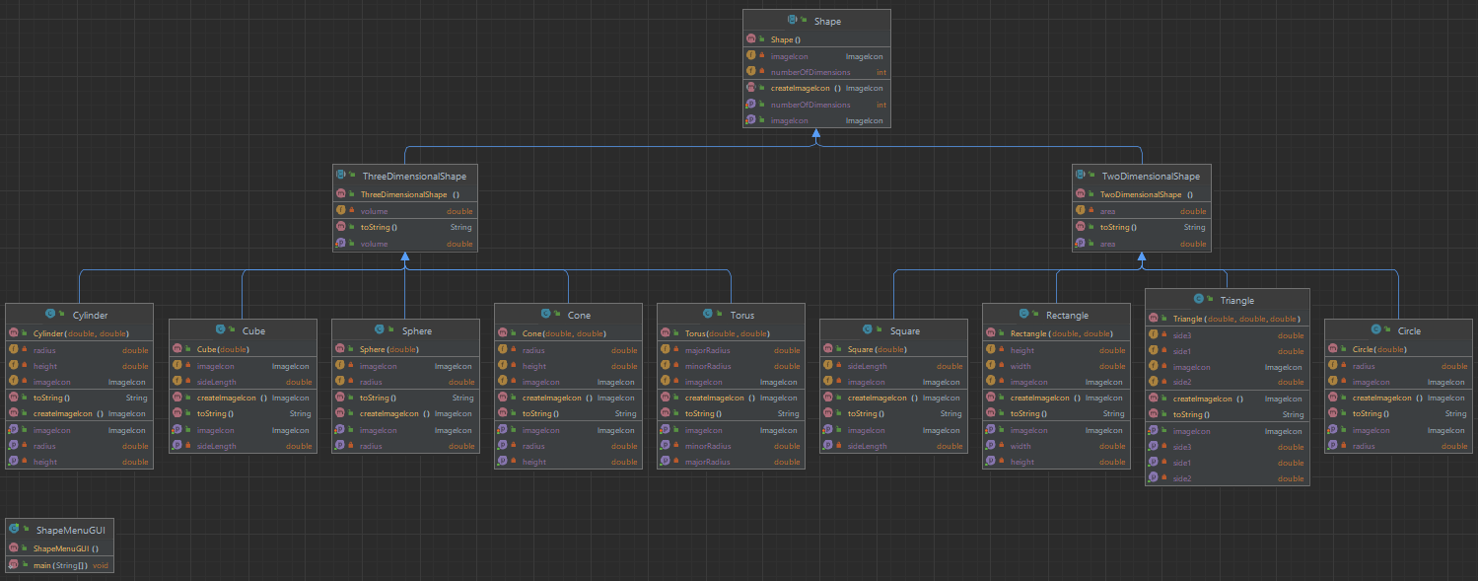**UML Diagram:**